

МІНІСТЕРСТВО ОСВІТИ І НАУКИ УКРАЇНИ

НАЦІОНАЛЬНИЙ ТЕХНІЧНИЙ УНІВЕРСИТЕТ УКРАЇНИ

“КИЇВСЬКИЙ ПОЛІТЕХНІЧНИЙ ІНСТИТУТ

ІМЕНІ ІГОРЯ СІКОРСЬКО”

Факультет прикладної математики

Кафедра системного програмування і спеціальних комп’ютерних систем

**Лабораторна робота №2**

З дисципліни «Комп’ютерна схемотехніка»

«Проектування тригерів на потенціальних елементах»

**Виконав:**

**студент III-го курсу**

**групи КВ-41**

**Горпинич-Радуженко Іван**

**Київ 2016**

**1.** S-тригер на елементах АБО-НЕ.

Таблиця переходів S-тригера.

|  |  |  |
| --- | --- | --- |
| S(t) | R(t) | Q(t+1) |
| 0 | 0 | Q(t) |
| 0 | 1 | 0 |
| 1 | 0 | 1 |
| 1 | 1 | 1 |

Таблиця функції збудження для БС на елементах АБО-НЕ.

|  |  |  |  |
| --- | --- | --- | --- |
| Q(t) | Q(t+1) | F1 | F2 |
| 0 | 0 | * | 0 |
| 0 | 1 | 0 | 1 |
| 1 | 0 | 1 | 0 |
| 1 | 1 | 0 | * |

Повна таблиця переходів.

|  |  |  |  |  |  |  |
| --- | --- | --- | --- | --- | --- | --- |
| C(t) | S(t) | R(t) | Q(t) | Q(t+1) | F1 | F2 |
| 0 | 0 | 0 | 0 | 0 | * | 0 |
| 0 | 0 | 0 | 1 | 1 | 0 | * |
| 0 | 0 | 1 | 0 | 0 | * | 0 |
| 0 | 0 | 1 | 1 | 1 | 0 | * |
| 0 | 1 | 0 | 0 | 0 | * | 0 |
| 0 | 1 | 0 | 1 | 1 | 0 | * |
| 0 | 1 | 1 | 0 | 0 | * | 0 |
| 0 | 1 | 1 | 1 | 1 | 0 | * |
| 1 | 0 | 0 | 0 | 0 | * | 0 |
| 1 | 0 | 0 | 1 | 1 | 0 | * |
| 1 | 0 | 1 | 0 | 0 | * | 0 |
| 1 | 0 | 1 | 1 | 0 | 1 | 0 |
| 1 | 1 | 0 | 0 | 1 | 0 | 1 |
| 1 | 1 | 0 | 1 | 1 | 0 | * |
| 1 | 1 | 1 | 0 | 1 | 0 | 1 |
| 1 | 1 | 1 | 1 | 1 | 0 | * |

Мінімізація F1 та F2.

|  |  |  |  |  |  |  |  |  |  |  |  |  |  |  |  |  |  |  |  |  |  |  |  |  |  |  |  |  |  |  |  |  |  |  |  |  |  |  |  |  |  |  |  |  |  |  |  |  |  |  |  |  |  |  |  |  |  |  |  |  |  |  |  |  |  |  |  |  |  |
| --- | --- | --- | --- | --- | --- | --- | --- | --- | --- | --- | --- | --- | --- | --- | --- | --- | --- | --- | --- | --- | --- | --- | --- | --- | --- | --- | --- | --- | --- | --- | --- | --- | --- | --- | --- | --- | --- | --- | --- | --- | --- | --- | --- | --- | --- | --- | --- | --- | --- | --- | --- | --- | --- | --- | --- | --- | --- | --- | --- | --- | --- | --- | --- | --- | --- | --- | --- | --- | --- |
| |  |  |  |  |  |  | | --- | --- | --- | --- | --- | --- | |  | S | |  |  | F1 | | C | 0 | 0 | 0 | * |  | | 0 | 0 | 1 | * | R | |  | * | 0 | 0 | * | |  | * | 0 | 0 | * |  | |  |  | Q | |  |  | | |  |  |  |  |  |  | | --- | --- | --- | --- | --- | --- | |  | S | |  |  | F2 | | C | 1 | * | * | 0 |  | | 1 | * | 0 | 0 | R | |  | 0 | * | * | 0 | |  | 0 | * | * | 0 |  | |  |  | Q | |  |  | |
|  |  |

Побудова.

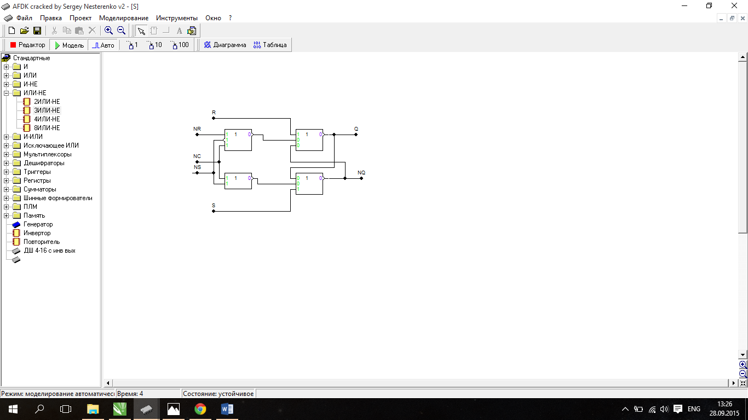

E-тригер на АБО-НЕ

Таблиця переходів E-тригера.

|  |  |  |
| --- | --- | --- |
| S(t) | R(t) | Q(t+1) |
| 0 | 0 | Q(t) |
| 0 | 1 | 0 |
| 1 | 0 | 1 |
| 1 | 1 | Q(t) |

Таблиця функції збудження для БС на елементах АБО-НЕ.

|  |  |  |  |
| --- | --- | --- | --- |
| Q(t) | Q(t+1) | F1 | F2 |
| 0 | 0 | * | 0 |
| 0 | 1 | 0 | 1 |
| 1 | 0 | 1 | 0 |
| 1 | 1 | 0 | * |

Повна таблиця переходів.

|  |  |  |  |  |  |  |
| --- | --- | --- | --- | --- | --- | --- |
| C | S | R | Q(t) | Q(t+1) | F1 | F2 |
| 0 | 0 | 0 | 0 | 0 | * | 0 |
| 0 | 0 | 0 | 1 | 1 | 0 | * |
| 0 | 0 | 1 | 0 | 0 | * | 0 |
| 0 | 0 | 1 | 1 | 1 | 0 | * |
| 0 | 1 | 0 | 0 | 0 | * | 0 |
| 0 | 1 | 0 | 1 | 1 | 0 | * |
| 0 | 1 | 1 | 0 | 0 | * | 0 |
| 0 | 1 | 1 | 1 | 1 | 0 | * |
| 1 | 0 | 0 | 0 | 0 | * | 0 |
| 1 | 0 | 0 | 1 | 1 | 0 | * |
| 1 | 0 | 1 | 0 | 0 | * | 0 |
| 1 | 0 | 1 | 1 | 0 | 1 | 0 |
| 1 | 1 | 0 | 0 | 1 | 0 | 1 |
| 1 | 1 | 0 | 1 | 1 | 0 | * |
| 1 | 1 | 1 | 0 | 0 | * | 0 |
| 1 | 1 | 1 | 1 | 1 | 0 | * |

Мінімізація F1 та F2.

|  |  |  |  |  |  |  |  |  |  |  |  |  |  |  |  |  |  |  |  |  |  |  |  |  |  |  |  |  |  |  |  |  |  |  |  |  |  |  |  |  |  |  |  |  |  |  |  |  |  |  |  |  |  |  |  |  |  |  |  |  |  |  |  |  |  |  |  |  |  |
| --- | --- | --- | --- | --- | --- | --- | --- | --- | --- | --- | --- | --- | --- | --- | --- | --- | --- | --- | --- | --- | --- | --- | --- | --- | --- | --- | --- | --- | --- | --- | --- | --- | --- | --- | --- | --- | --- | --- | --- | --- | --- | --- | --- | --- | --- | --- | --- | --- | --- | --- | --- | --- | --- | --- | --- | --- | --- | --- | --- | --- | --- | --- | --- | --- | --- | --- | --- | --- | --- |
| |  |  |  |  |  |  | | --- | --- | --- | --- | --- | --- | |  | S | |  |  | F1 | | C | 0 | 0 | 0 | * |  | | * | 0 | 1 | * | R | |  | * | 0 | 0 | * | |  | * | 0 | 0 | * |  | |  |  | Q | |  |  | | |  |  |  |  |  |  | | --- | --- | --- | --- | --- | --- | |  | S | |  |  | F2 | | C | 1 | * | * | 0 |  | | 0 | * | 0 | 0 | R | |  | 0 | * | * | 0 | |  | 0 | * | * | 0 |  | |  |  | Q | |  |  | |

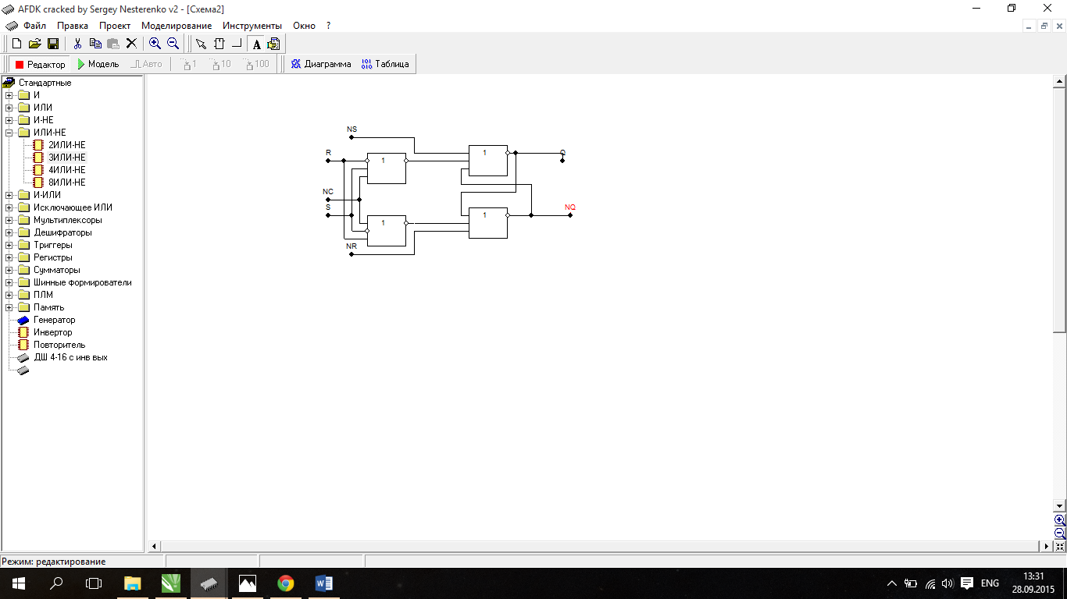

RS-тригер на І-НЕ

Таблиця переходів RS-тригера.

|  |  |  |
| --- | --- | --- |
| S(t) | R(t) | Q(t+1) |
| 0 | 0 | Q(t) |
| 0 | 1 | 0 |
| 1 | 0 | 1 |
| 1 | 1 | - |

Таблиця функції збудження для БС на елементах І-НЕ.

|  |  |  |  |
| --- | --- | --- | --- |
| Q(t) | Q(t+1) | F1 | F2 |
| 0 | 0 | 1 | * |
| 0 | 1 | 0 | 1 |
| 1 | 0 | 1 | 0 |
| 1 | 1 | * | 1 |

Повна таблиця переходів.

|  |  |  |  |  |  |  |
| --- | --- | --- | --- | --- | --- | --- |
| C | S | R | Q(t) | Q(t+1) | F1 | F2 |
| 0 | 0 | 0 | 0 | 0 | 1 | * |
| 0 | 0 | 0 | 1 | 1 | * | 1 |
| 0 | 0 | 1 | 0 | 0 | 1 | * |
| 0 | 0 | 1 | 1 | 1 | * | 1 |
| 0 | 1 | 0 | 0 | 0 | 1 | * |
| 0 | 1 | 0 | 1 | 1 | * | 1 |
| 0 | 1 | 1 | 0 | 0 | 1 | * |
| 0 | 1 | 1 | 1 | 1 | * | 1 |
| 1 | 0 | 0 | 0 | 0 | 1 | * |
| 1 | 0 | 0 | 1 | 1 | * | 1 |
| 1 | 0 | 1 | 0 | 0 | 1 | * |
| 1 | 0 | 1 | 1 | 0 | 1 | 0 |
| 1 | 1 | 0 | 0 | 1 | 0 | 1 |
| 1 | 1 | 0 | 1 | 1 | * | 1 |
| 1 | 1 | 1 | 0 | -- | - | - |
| 1 | 1 | 1 | 1 | -- | - | - |

Мінімізація F1 та F2.

|  |  |  |  |  |  |  |  |  |  |  |  |  |  |  |  |  |  |  |  |  |  |  |  |  |  |  |  |  |  |  |  |  |  |  |  |  |  |  |  |  |  |  |  |  |  |  |  |  |  |  |  |  |  |  |  |  |  |  |  |  |  |  |  |  |  |  |  |  |  |
| --- | --- | --- | --- | --- | --- | --- | --- | --- | --- | --- | --- | --- | --- | --- | --- | --- | --- | --- | --- | --- | --- | --- | --- | --- | --- | --- | --- | --- | --- | --- | --- | --- | --- | --- | --- | --- | --- | --- | --- | --- | --- | --- | --- | --- | --- | --- | --- | --- | --- | --- | --- | --- | --- | --- | --- | --- | --- | --- | --- | --- | --- | --- | --- | --- | --- | --- | --- | --- | --- |
| |  |  |  |  |  |  | | --- | --- | --- | --- | --- | --- | |  | S | |  |  | F1 | | C | 0 | * | * | 1 |  | | - | - | 1 | 1 | R | |  | 1 | * | * | 1 | |  | 1 | * | * | 1 |  | |  |  | Q | |  |  | | |  |  |  |  |  |  | | --- | --- | --- | --- | --- | --- | |  | S | |  |  | F2 | | C | 1 | 1 | 1 | * |  | | - | - | 0 | * | R | |  | * | 1 | 1 | * | |  | * | 1 | 1 | * |  | |  |  | Q | |  |  | |

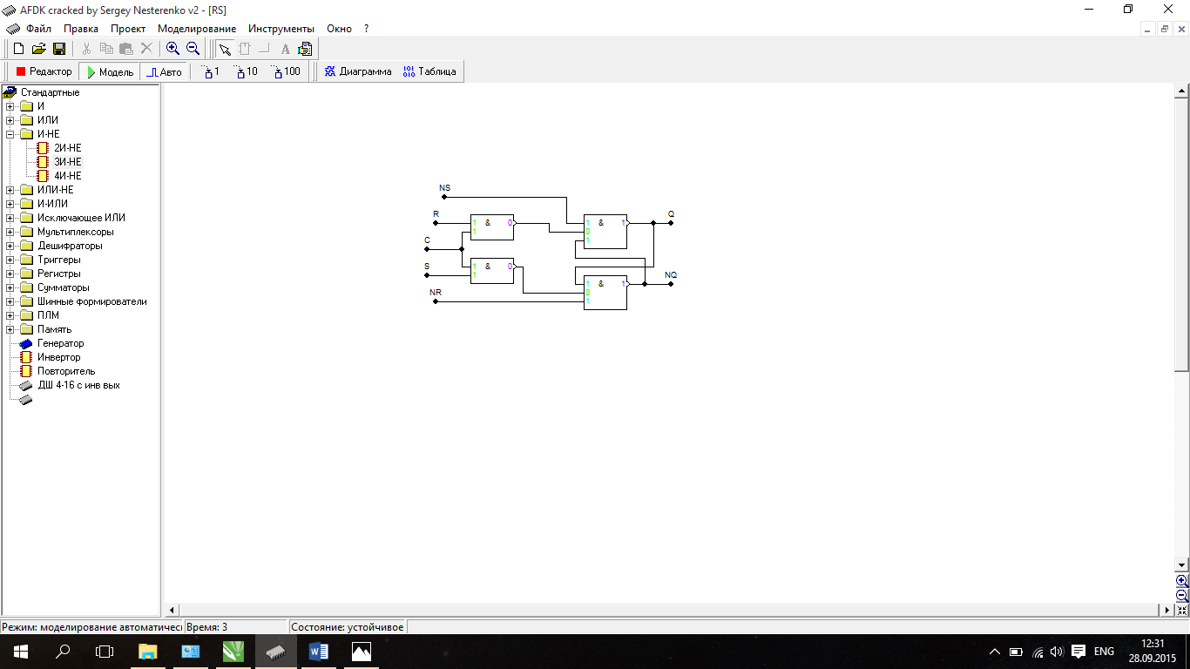

R-тригер на І-НЕ

Таблиця переходів R-тригера.

|  |  |  |
| --- | --- | --- |
| S(t) | R(t) | Q(t+1) |
| 0 | 0 | Q(t) |
| 0 | 1 | 0 |
| 1 | 0 | 1 |
| 1 | 1 | 0 |

Таблиця функції збудження для БС на елементах І-НЕ.

|  |  |  |  |
| --- | --- | --- | --- |
| Q(t) | Q(t+1) | F1 | F2 |
| 0 | 0 | 1 | * |
| 0 | 1 | 0 | 1 |
| 1 | 0 | 1 | 0 |
| 1 | 1 | * | 1 |

Повна таблиця переходів.

|  |  |  |  |  |  |  |
| --- | --- | --- | --- | --- | --- | --- |
| C | S | R | Q(t) | Q(t+1) | F1 | F2 |
| 0 | 0 | 0 | 0 | 0 | 1 | * |
| 0 | 0 | 0 | 1 | 1 | * | 1 |
| 0 | 0 | 1 | 0 | 0 | 1 | * |
| 0 | 0 | 1 | 1 | 1 | * | 1 |
| 0 | 1 | 0 | 0 | 0 | 1 | * |
| 0 | 1 | 0 | 1 | 1 | * | 1 |
| 0 | 1 | 1 | 0 | 0 | 1 | * |
| 0 | 1 | 1 | 1 | 1 | * | 1 |
| 1 | 0 | 0 | 0 | 0 | 1 | * |
| 1 | 0 | 0 | 1 | 1 | * | 1 |
| 1 | 0 | 1 | 0 | 0 | 1 | * |
| 1 | 0 | 1 | 1 | 0 | 1 | 0 |
| 1 | 1 | 0 | 0 | 1 | 0 | 1 |
| 1 | 1 | 0 | 1 | 1 | * | 1 |
| 1 | 1 | 1 | 0 | 0 | 1 | * |
| 1 | 1 | 1 | 1 | 0 | 1 | 0 |

Мінімізація F1 та F2.

|  |  |  |  |  |  |  |  |  |  |  |  |  |  |  |  |  |  |  |  |  |  |  |  |  |  |  |  |  |  |  |  |  |  |  |  |  |  |  |  |  |  |  |  |  |  |  |  |  |  |  |  |  |  |  |  |  |  |  |  |  |  |  |  |  |  |  |  |  |  |
| --- | --- | --- | --- | --- | --- | --- | --- | --- | --- | --- | --- | --- | --- | --- | --- | --- | --- | --- | --- | --- | --- | --- | --- | --- | --- | --- | --- | --- | --- | --- | --- | --- | --- | --- | --- | --- | --- | --- | --- | --- | --- | --- | --- | --- | --- | --- | --- | --- | --- | --- | --- | --- | --- | --- | --- | --- | --- | --- | --- | --- | --- | --- | --- | --- | --- | --- | --- | --- | --- |
| |  |  |  |  |  |  | | --- | --- | --- | --- | --- | --- | |  | S | |  |  | F1 | | C | 0 | * | * | 1 |  | | 1 | 1 | 1 | 1 | R | |  | 1 | * | * | 1 | |  | 1 | * | * | 1 |  | |  |  | Q | |  |  | | |  |  |  |  |  |  | | --- | --- | --- | --- | --- | --- | |  | S | |  |  | F2 | | C | 1 | 1 | 1 | * |  | | * | 0 | 0 | * | R | |  | * | 1 | 1 | * | |  | * | 1 | 1 | * |  | |  |  | Q | |  |  | |

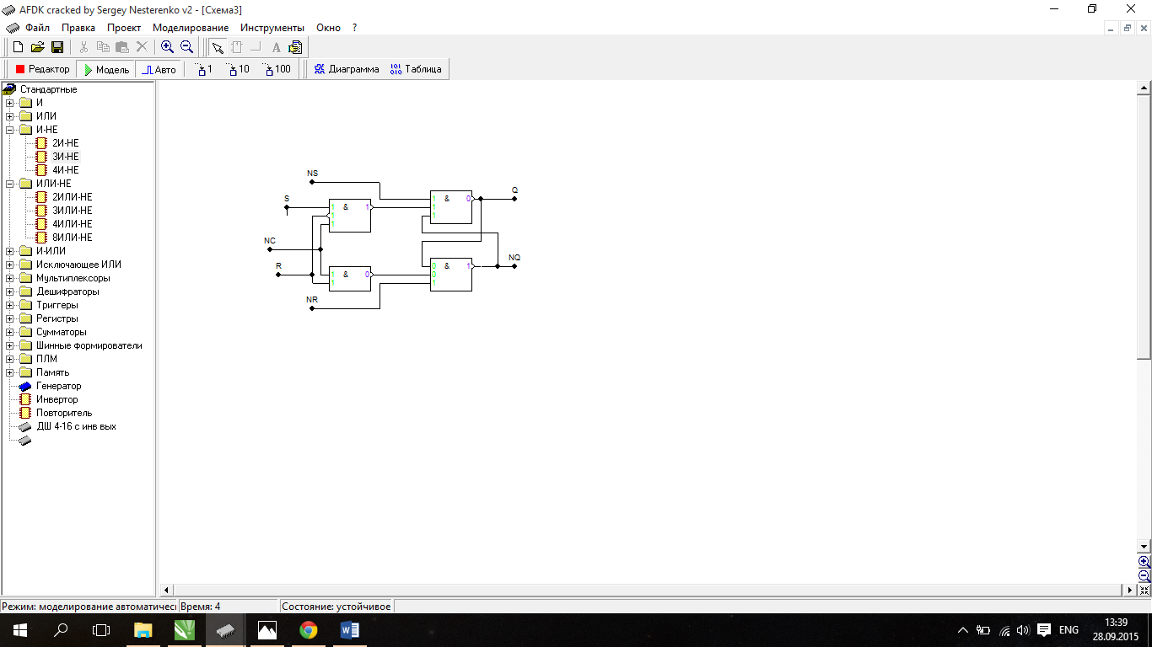

**2.**D-тригер за MS схемою І-НЕ

Таблиця переходів D-тригера.

|  |  |
| --- | --- |
| D(t) | Q(t+1) |
| 0 | 0 |
| 1 | 1 |

Таблиця функції збудження для БС на елементах І-НЕ.

|  |  |  |  |
| --- | --- | --- | --- |
| Q(t) | Q(t+1) | F1 | F2 |
| 0 | 0 | 1 | * |
| 0 | 1 | 0 | 1 |
| 1 | 0 | 1 | 0 |
| 1 | 1 | * | 1 |

Повна таблиця переходів.

|  |  |  |  |  |  |
| --- | --- | --- | --- | --- | --- |
| C | D | Q(t) | Q(t+1) | F1 | F2 |
| 0 | 0 | 0 | 0 | 1 | * |
| 0 | 0 | 1 | 1 | * | 1 |
| 0 | 1 | 0 | 0 | 1 | * |
| 0 | 1 | 1 | 1 | * | 1 |
| 1 | 0 | 0 | 0 | 1 | * |
| 1 | 0 | 1 | 0 | 1 | 0 |
| 1 | 1 | 0 | 1 | 0 | 1 |
| 1 | 1 | 1 | 1 | * | 1 |

Мінімізація F1 та F2.

|  |  |  |  |  |  |  |  |  |  |  |  |  |  |  |  |  |  |  |  |  |  |  |  |  |  |  |  |  |  |  |  |  |  |  |  |  |  |  |  |  |  |  |  |  |  |  |  |
| --- | --- | --- | --- | --- | --- | --- | --- | --- | --- | --- | --- | --- | --- | --- | --- | --- | --- | --- | --- | --- | --- | --- | --- | --- | --- | --- | --- | --- | --- | --- | --- | --- | --- | --- | --- | --- | --- | --- | --- | --- | --- | --- | --- | --- | --- | --- | --- |
| |  |  |  |  |  |  | | --- | --- | --- | --- | --- | --- | |  | D | |  |  | F1 | | C | 0 | * | 1 | 1 |  | | 1 | * | * | 1 |  | |  |  | Q | |  |  | | |  |  |  |  |  |  | | --- | --- | --- | --- | --- | --- | |  | D | |  |  | F2 | | C | 1 | 1 | 0 | * |  | | * | 1 | 1 | * |  | |  |  | Q | |  |  | |

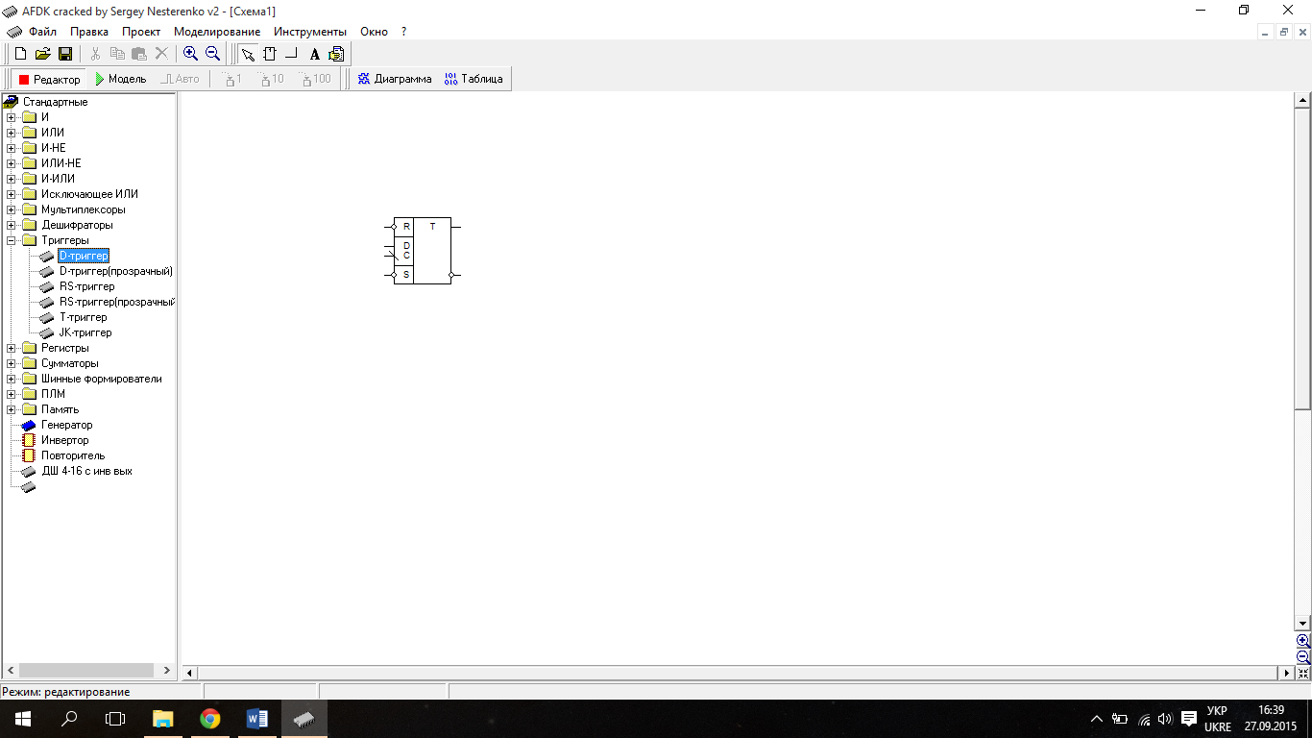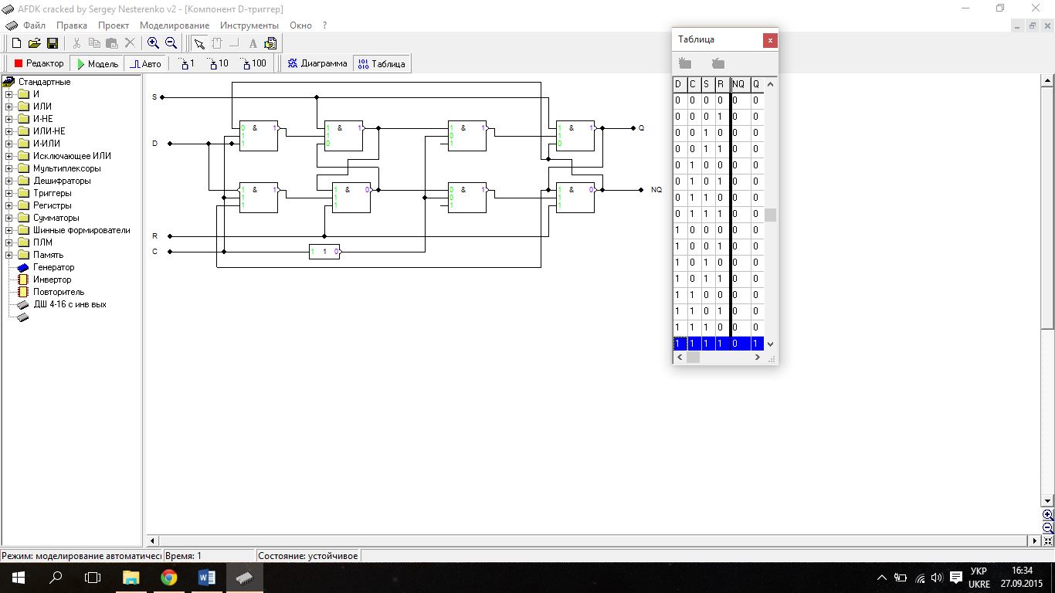

JK-тригер MS на I-НЕ

Таблиця переходів JK-тригера.

|  |  |  |
| --- | --- | --- |
| J(t) | K(t) | Q(t+1) |
| 0 | 0 | Q(t) |
| 0 | 1 | 0 |
| 1 | 0 | 1 |
| 1 | 1 | NQ(t) |

Таблиця функції збудження для БС на елементах І-НЕ.

|  |  |  |  |
| --- | --- | --- | --- |
| Q(t) | Q(t+1) | F1 | F2 |
| 0 | 0 | 1 | * |
| 0 | 1 | 0 | 1 |
| 1 | 0 | 1 | 0 |
| 1 | 1 | * | 1 |

Повна таблиця переходів.

|  |  |  |  |  |  |  |
| --- | --- | --- | --- | --- | --- | --- |
| C | J | K | Q(t) | Q(t+1) | F1 | F2 |
| 0 | 0 | 0 | 0 | 0 | 1 | * |
| 0 | 0 | 0 | 1 | 1 | * | 1 |
| 0 | 0 | 1 | 0 | 0 | 1 | * |
| 0 | 0 | 1 | 1 | 1 | * | 1 |
| 0 | 1 | 0 | 0 | 0 | 1 | * |
| 0 | 1 | 0 | 1 | 1 | * | 1 |
| 0 | 1 | 1 | 0 | 0 | 1 | * |
| 0 | 1 | 1 | 1 | 1 | * | 1 |
| 1 | 0 | 0 | 0 | 0 | 1 | * |
| 1 | 0 | 0 | 1 | 1 | * | 1 |
| 1 | 0 | 1 | 0 | 0 | 1 | * |
| 1 | 0 | 1 | 1 | 0 | 1 | 0 |
| 1 | 1 | 0 | 0 | 1 | 0 | 1 |
| 1 | 1 | 0 | 1 | 1 | * | 1 |
| 1 | 1 | 1 | 0 | 1 | 0 | 1 |
| 1 | 1 | 1 | 1 | 0 | 1 | 0 |

Мінімізація F1 та F2.

|  |  |  |  |  |  |  |  |  |  |  |  |  |  |  |  |  |  |  |  |  |  |  |  |  |  |  |  |  |  |  |  |  |  |  |  |  |  |  |  |  |  |  |  |  |  |  |  |  |  |  |  |  |  |  |  |  |  |  |  |  |  |  |  |  |  |  |  |  |  |
| --- | --- | --- | --- | --- | --- | --- | --- | --- | --- | --- | --- | --- | --- | --- | --- | --- | --- | --- | --- | --- | --- | --- | --- | --- | --- | --- | --- | --- | --- | --- | --- | --- | --- | --- | --- | --- | --- | --- | --- | --- | --- | --- | --- | --- | --- | --- | --- | --- | --- | --- | --- | --- | --- | --- | --- | --- | --- | --- | --- | --- | --- | --- | --- | --- | --- | --- | --- | --- | --- |
| |  |  |  |  |  |  | | --- | --- | --- | --- | --- | --- | |  | J | |  |  | F1 | | C | 0 | * | * | 1 |  | | 0 | 1 | 1 | 1 | K | |  | 1 | * | * | 1 | |  | 1 | * | * | 1 |  | |  |  | Q | |  |  | | |  |  |  |  |  |  | | --- | --- | --- | --- | --- | --- | |  | J | |  |  | F2 | | C | 1 | 1 | 1 | * |  | | 1 | 0 | 0 | * | K | |  | * | 1 | 1 | * | |  | * | 1 | 1 | * |  | |  |  | Q | |  |  | |

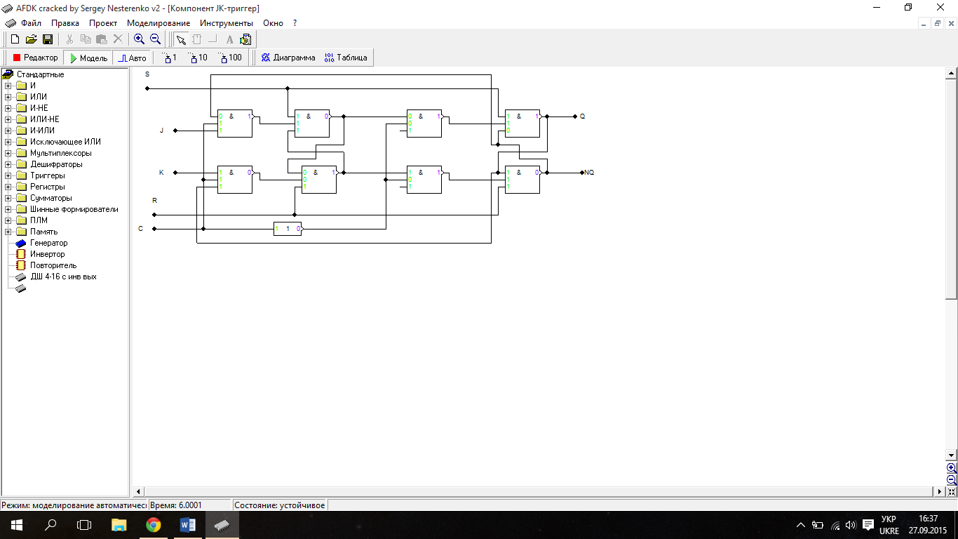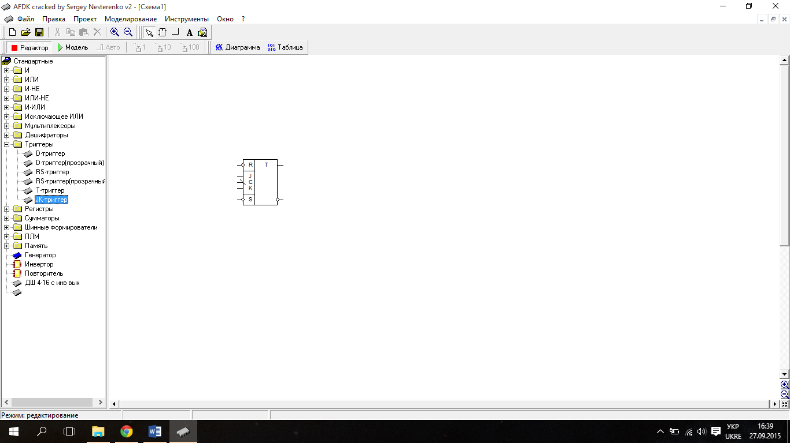Т-Тригер за MS схемою АБО-НЕ

Таблиця переходів T-тригера.

|  |  |
| --- | --- |
| Т(t) | Q(t+1) |
| 0 | Q(t) |
| 1 | NQ(t) |

Таблиця функції збудження для БС на елементах АБО-НЕ.

|  |  |  |  |
| --- | --- | --- | --- |
| Q(t) | Q(t+1) | F1 | F2 |
| 0 | 0 | * | 0 |
| 0 | 1 | 0 | 1 |
| 1 | 0 | 1 | 0 |
| 1 | 1 | 0 | * |

Повна таблиця переходів.

|  |  |  |  |  |  |
| --- | --- | --- | --- | --- | --- |
| C | T | Q(t) | Q(t+1) | F1 | F2 |
| 0 | 0 | 0 | 0 | * | 0 |
| 0 | 0 | 1 | 1 | 0 | * |
| 0 | 1 | 0 | 0 | * | 0 |
| 0 | 1 | 1 | 1 | 0 | * |
| 1 | 0 | 0 | 0 | * | 0 |
| 1 | 0 | 1 | 1 | 0 | * |
| 1 | 1 | 0 | 1 | 0 | 1 |
| 1 | 1 | 1 | 0 | 1 | 0 |

Мінімізація F1 та F2.

|  |  |  |  |  |  |  |  |  |  |  |  |  |  |  |  |  |  |  |  |  |  |  |  |  |  |  |  |  |  |  |  |  |  |  |  |  |  |  |  |  |  |  |  |  |  |  |  |
| --- | --- | --- | --- | --- | --- | --- | --- | --- | --- | --- | --- | --- | --- | --- | --- | --- | --- | --- | --- | --- | --- | --- | --- | --- | --- | --- | --- | --- | --- | --- | --- | --- | --- | --- | --- | --- | --- | --- | --- | --- | --- | --- | --- | --- | --- | --- | --- |
| |  |  |  |  |  |  | | --- | --- | --- | --- | --- | --- | |  | T | |  |  | F1 | | C | 0 | 1 | 0 | * |  | | * | 0 | 0 | * |  | |  |  | Q | |  |  | | |  |  |  |  |  |  | | --- | --- | --- | --- | --- | --- | |  | T | |  |  | F2 | | C | 1 | 0 | * | 0 |  | | 0 | * | * | 0 |  | |  |  | Q | |  |  | |

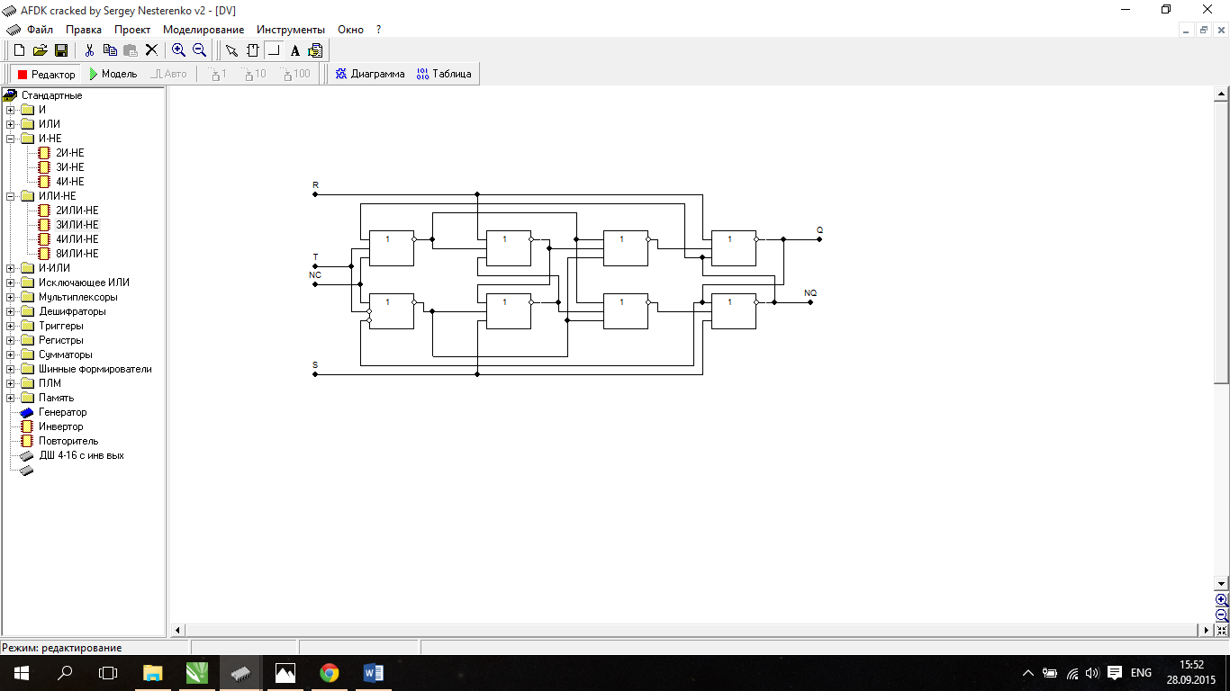

DV-тригер MS на АБО-НЕ

Таблиця переходів DV-тригера.

|  |  |  |
| --- | --- | --- |
| D(t) | V(t) | Q(t+1) |
| 0 | 0 | Q(t) |
| 0 | 1 | Q(t) |
| 1 | 0 | 0 |
| 1 | 1 | 1 |

Таблиця функції збудження для БС на елементах АБО-НЕ.

|  |  |  |  |
| --- | --- | --- | --- |
| Q(t) | Q(t+1) | F1 | F2 |
| 0 | 0 | * | 0 |
| 0 | 1 | 0 | 1 |
| 1 | 0 | 1 | 0 |
| 1 | 1 | 0 | * |

Повна таблиця переходів.

|  |  |  |  |  |  |  |
| --- | --- | --- | --- | --- | --- | --- |
| C | D | V | Q(t) | Q(t+1) | F1 | F2 |
| 0 | 0 | 0 | 0 | 0 | * | 0 |
| 0 | 0 | 0 | 1 | 1 | 0 | * |
| 0 | 0 | 1 | 0 | 0 | * | 0 |
| 0 | 0 | 1 | 1 | 1 | 0 | * |
| 0 | 1 | 0 | 0 | 0 | * | 0 |
| 0 | 1 | 0 | 1 | 1 | 0 | * |
| 0 | 1 | 1 | 0 | 0 | * | 0 |
| 0 | 1 | 1 | 1 | 1 | 0 | * |
| 1 | 0 | 0 | 0 | 0 | * | 0 |
| 1 | 0 | 0 | 1 | 1 | 0 | * |
| 1 | 0 | 1 | 0 | 0 | * | 0 |
| 1 | 0 | 1 | 1 | 1 | 0 | * |
| 1 | 1 | 0 | 0 | 0 | * | 0 |
| 1 | 1 | 0 | 1 | 0 | 1 | 0 |
| 1 | 1 | 1 | 0 | 1 | 0 | 1 |
| 1 | 1 | 1 | 1 | 1 | 0 | * |

Мінімізація F1 та F2.

|  |  |  |  |  |  |  |  |  |  |  |  |  |  |  |  |  |  |  |  |  |  |  |  |  |  |  |  |  |  |  |  |  |  |  |  |  |  |  |  |  |  |  |  |  |  |  |  |  |  |  |  |  |  |  |  |  |  |  |  |  |  |  |  |  |  |  |  |  |  |
| --- | --- | --- | --- | --- | --- | --- | --- | --- | --- | --- | --- | --- | --- | --- | --- | --- | --- | --- | --- | --- | --- | --- | --- | --- | --- | --- | --- | --- | --- | --- | --- | --- | --- | --- | --- | --- | --- | --- | --- | --- | --- | --- | --- | --- | --- | --- | --- | --- | --- | --- | --- | --- | --- | --- | --- | --- | --- | --- | --- | --- | --- | --- | --- | --- | --- | --- | --- | --- | --- |
| |  |  |  |  |  |  | | --- | --- | --- | --- | --- | --- | |  | D | |  |  | F1 | | C | * | 1 | 0 | * |  | | 0 | 0 | 0 | * | V | |  | * | 0 | 0 | * | |  | * | 0 | 0 | * |  | |  |  | Q | |  |  | | |  |  |  |  |  |  | | --- | --- | --- | --- | --- | --- | |  | D | |  |  | F2 | | C | 0 | 0 | * | 0 |  | | 1 | * | * | 0 | V | |  | 0 | * | * | 0 | |  | 0 | * | * | 0 |  | |  |  | Q | |  |  | |

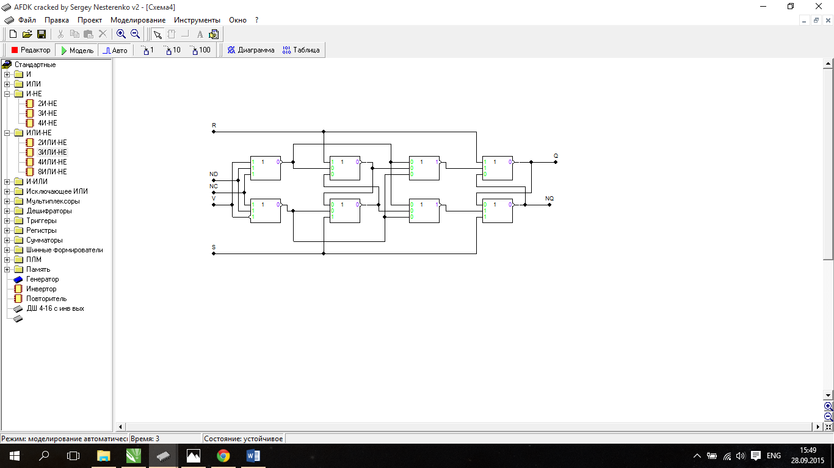

**3**.Тригер на трьох бістабільних схемаx на елементах І-НЕ

Таблиця переходів тригера.

|  |  |  |
| --- | --- | --- |
| X1 | X2 | Q(t+1) |
| 0 | 0 | 1 |
| 0 | 1 | 0 |
| 1 | 0 | 0 |
| 1 | 1 | NQ(t) |

Таблиця функції збудження для БС на елементах І-НЕ.

|  |  |  |  |
| --- | --- | --- | --- |
| Q(t) | Q(t+1) | F1 | F2 |
| 0 | 0 | 1 | * |
| 0 | 1 | 0 | 1 |
| 1 | 0 | 1 | 0 |
| 1 | 1 | * | 1 |

Повна таблиця переходів.

|  |  |  |  |  |  |  |
| --- | --- | --- | --- | --- | --- | --- |
| C | X1 | X2 | Q(t) | Q(t+1) | F1 | F2 |
| 0 | 0 | 0 | 0 | 0 | 1 | * |
| 0 | 0 | 0 | 1 | 1 | * | 1 |
| 0 | 0 | 1 | 0 | 0 | 1 | * |
| 0 | 0 | 1 | 1 | 1 | * | 1 |
| 0 | 1 | 0 | 0 | 0 | 1 | * |
| 0 | 1 | 0 | 1 | 1 | * | 1 |
| 0 | 1 | 1 | 0 | 0 | 1 | * |
| 0 | 1 | 1 | 1 | 1 | * | 1 |
| 1 | 0 | 0 | 0 | 1 | 0 | 1 |
| 1 | 0 | 0 | 1 | 1 | * | 1 |
| 1 | 0 | 1 | 0 | 0 | 1 | * |
| 1 | 0 | 1 | 1 | 0 | 1 | 0 |
| 1 | 1 | 0 | 0 | 0 | 1 | * |
| 1 | 1 | 0 | 1 | 0 | 1 | 0 |
| 1 | 1 | 1 | 0 | 1 | 0 | 1 |
| 1 | 1 | 1 | 1 | 0 | 1 | 0 |

Мінімізація F1 та F2.

|  |  |  |  |  |  |  |  |  |  |  |  |  |  |  |  |  |  |  |  |  |  |  |  |  |  |  |  |  |  |  |  |  |  |  |  |  |  |  |  |  |  |  |  |  |  |  |  |  |  |  |  |  |  |  |  |  |  |  |  |  |  |  |  |  |  |  |  |  |  |
| --- | --- | --- | --- | --- | --- | --- | --- | --- | --- | --- | --- | --- | --- | --- | --- | --- | --- | --- | --- | --- | --- | --- | --- | --- | --- | --- | --- | --- | --- | --- | --- | --- | --- | --- | --- | --- | --- | --- | --- | --- | --- | --- | --- | --- | --- | --- | --- | --- | --- | --- | --- | --- | --- | --- | --- | --- | --- | --- | --- | --- | --- | --- | --- | --- | --- | --- | --- | --- | --- |
| |  |  |  |  |  |  | | --- | --- | --- | --- | --- | --- | |  | X1 | |  |  | F1 | | C | 1 | 1 | * | 0 |  | | 0 | 1 | 1 | 1 | X2 | |  | 1 | * | * | 1 | |  | 1 | * | * | 1 |  | |  |  | Q | |  |  | | |  |  |  |  |  |  | | --- | --- | --- | --- | --- | --- | |  | X1 | |  |  | F2 | | C | * | 0 | 1 | 1 |  | | 1 | 0 | 0 | * | X2 | |  | * | 1 | 1 | * | |  | * | 1 | 1 | * |  | |  |  | Q | |  |  | |

